

ESC Control Test

Document Number : XXX
Date : 2026-10-08
Revision : 01

Approval Sheet

Title | : | ESC Control Test
Document Number | : | XXX
Revision | : | 01
Date | : | 2026/10/08
Department | : | Denel Aerospace Engineering
File Name | : | ESC PWM Test.docx
Classification | : | RESTRICTED
Key Words: | : | Electronic Speed Control, Microcontroller, Pulse width Modulation

Prepared By : Date :
………………………………………… ……………………….
Engineer: Itumeleng Theletsane

Checked By : Date :
………………………………………… ………………………..
Chief Engineer:

Checked By : Date :
………………………………………… ………………………..
Systems Engineer:
Distribution Sheet

Physical Distribution List
Name/Title | Address | Copy

Electronic Distribution List
Name/Title | Address

Change Control
Date | Revision | Change Summary | ECP Number
2026/10/08 | 1 | New Document | N/A

Abbreviations and Acronyms

ESC | Electronic Speed Control
PWM | Pulse Width Modulation
Min | Minimum
Max | Maximum
RPM | Rotations Per Minute
TBD | To Be Determined

Table of Contents

Physical Distribution List 2
Electronic Distribution List 2
Change Control 3
Abbreviations and Acronyms 4
Table of Contents 5
List of Tables 6
1 Introduction 6
2 References 6
4 Items Required 7
5 Testing the PWM signal on the oscilloscope 8

List of Tables
Table 1: Test Procedure and results 8

Introduction
This plan presents a method by which to test the PWM signal sent to the ESC and the effective control of the motors. The source of the signal will originate from a STM Nucleo-F767ZI micro-controller.
Pulse variations to be tested:
- 1000ms – The signal to tell the motors to stop
- 1100ms – The signal to tell the motors to perform the min rpm
- 1940ms – The signal to tell the motors to perform the max rpm
- 1100 to 1940 – Variations of signals between the 1100 and 1940

Items Required, Connections and Specification
3.1 Items Required
    - STM Nucleo-F767ZI Development Board
    - Min of 9 Jumper Cables
    - J Gowens, J Pead Development Board
    - Oscilloscope
    - Oscilloscope probes

  - Pin Connection

Pin | Function | Mode | Connects to
PF8 | ADC3_IN6 | Analogue | Potentiometer wiper
PD14 | TIM4_CH3 | Alternate function AF2, push-pull | Motor driver PWM input
PB14 | Direction A | Output push-pull, no pull | Motor driver direction input 1
PB7 | Direction B | Output push-pull, no pull | Motor driver direction input 2
PC13 | User button B1 | External interrupt, falling edge | On-board blue button

  - Specifications
    - PWM output
      - TIM4 channel 3 produces a 500 Hz PWM signal on PD14, and the potentiometer sets its duty cycle.
    - User button and interrupt
      - Pressing the on-board blue button fires an external interrupt that flips the motor rotation on and off.

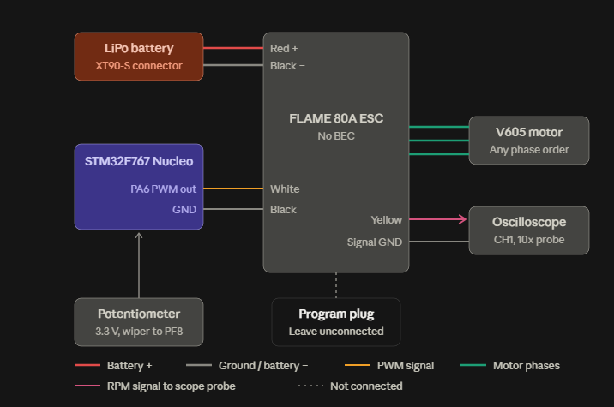
Figure 1: ESC Connection 1

Testing the PWM signal on the oscilloscope
Table 1: Test Procedure and results
 | Test Procedure | Results / Notes
 | Connect and power on the micro controller by supplying 5 – 12V of power. The Blue Led(LD2) should turn on.
 | Press the B1 User button (Blue button), LD2 should turn off and LD3 should turn on.
 | While LD2 is illuminated, connect the oscilloscope probes to PD14 and any ground pin outs on the micro controller and you should read a frequency of 500Hz and a pulse of 1000ms.
 | While LD3 is illuminated, connect the oscilloscope probes to PD14 and any ground pin outs on the micro controller and you should read a frequency of 500Hz and a pulse of 1100ms.
 | While LD2 is illuminated, Connect a potentiometer to PF8. Connect the oscilloscope probes to PD14 and any ground pin outs on the micro controller. Decrease the output voltage to the pin PF8 from 3.3 to 0V and increase it from 0V to 3.3V, you should read a frequency of 500Hz and a pulse of 1000ms.
 | While LD3 is illuminated, Connect a potentiometer to PF8. Connect the oscilloscope probes to PD14 and any ground pin outs on the micro controller. Decrease the output voltage to the pin PF8 from 3.3 to 0V and increase it from 0V to 3.3V, you should read a frequency of 500Hz and a pulse varying from 1100ms to 1940ms.
 | While LD2 is illuminated, connect the ESC with the guidance of figure 1. The motors should not be spinning
 | While LD3 is illuminated, connect the ESC with the guidance of figure 1, and ensure that the potentiometer is producing an output of 0V. The motors should be spinning with a low rpm.
 | While LD3 is illuminated, connect the ESC with the guidance of figure 1, and ensure that the potentiometer is producing an output of 3.3V. The motors should be spinning with a Max rpm.

